Министерство образования Республики Беларусь

Учреждение образования
БелорусскиЙ государственный университет
информатики и радиоэлектроники

Факультет компьютерных систем и сетей

Кафедра программного обеспечения информационных технологий

оТЧЕТ
по лабораторной работе

на тему:

Изучение объекта canvas

Выполнили  Студенты гр. 451001 |  | В.И. Волынец  Н.Д. Иванов  М.С. Смолян
Проверил |  | Асс. Е.Е. Фадеева
Минск, 2025
Задание на лабораторную работу и эскиз работы программы

Используя объект Canvas, нарисовать мультфильм небольшого хронометража (~30 секунд). Сюжет основывать на основе выданного преподавателем вида спорта (бег с препятствиями).

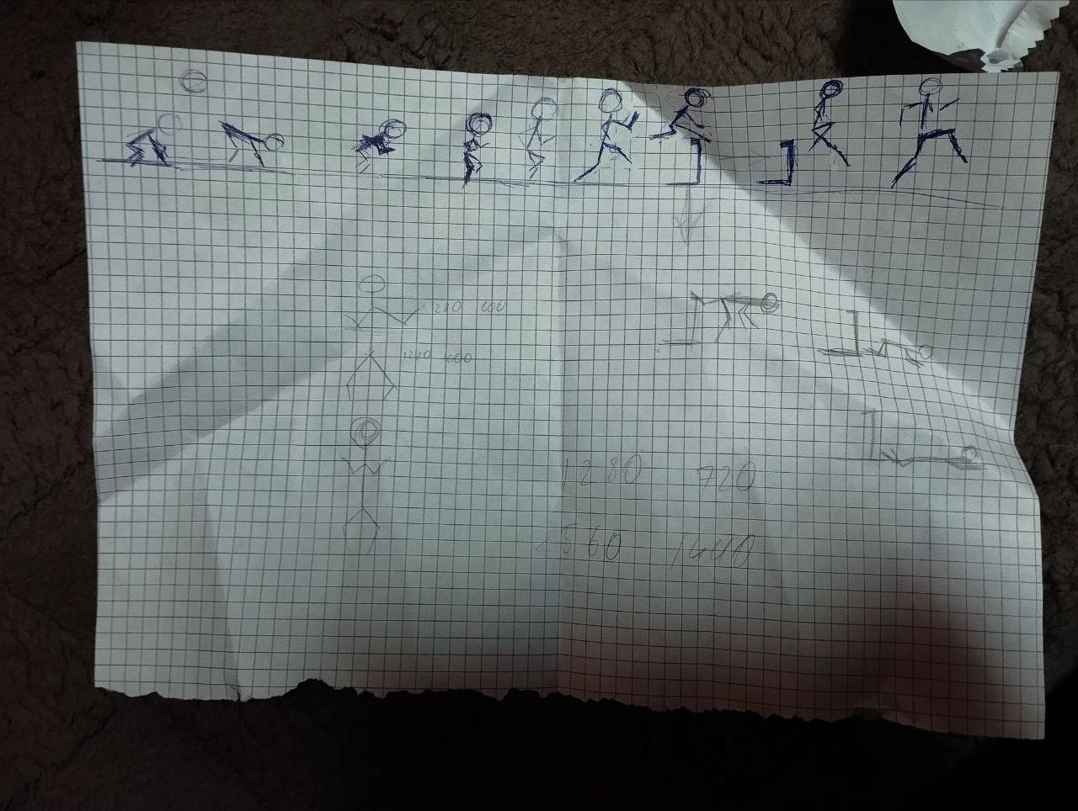

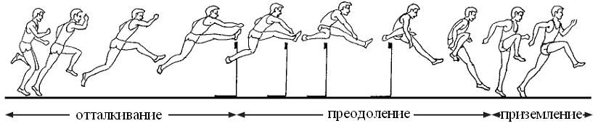
Выполнение

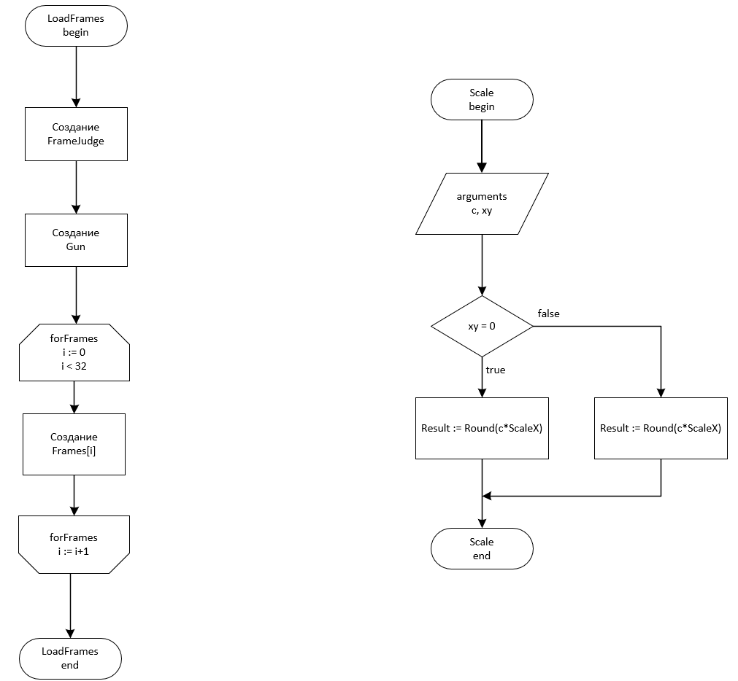

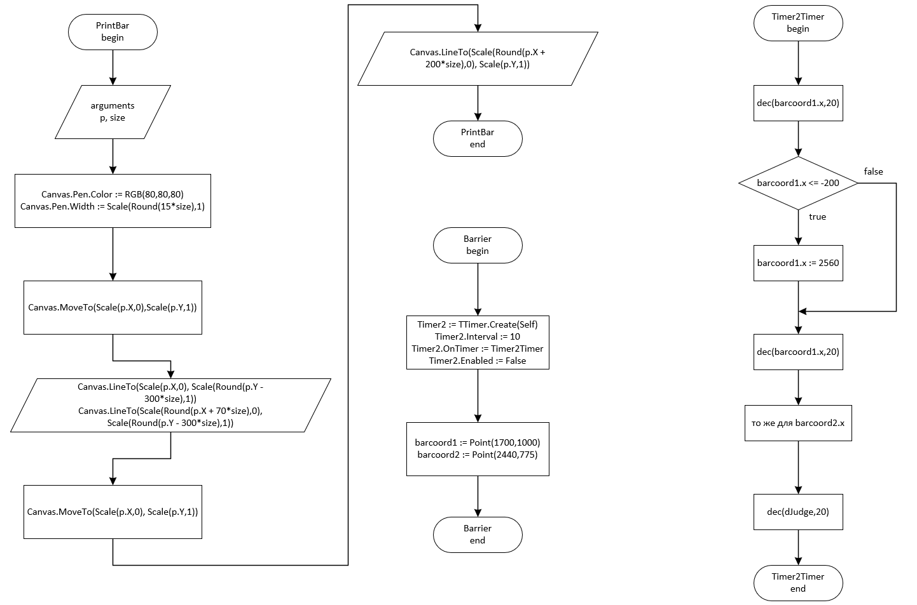

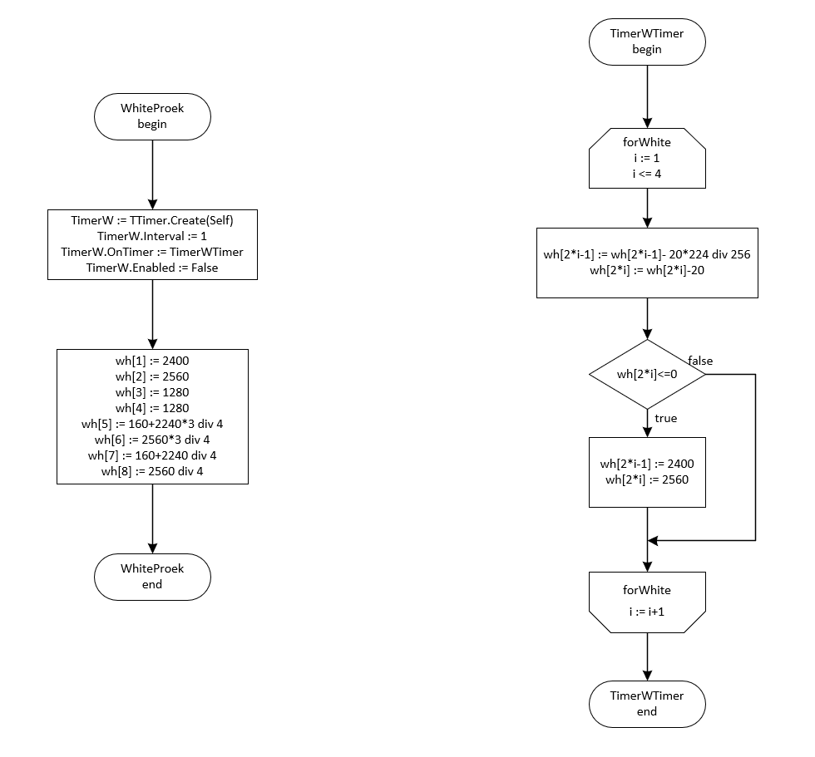

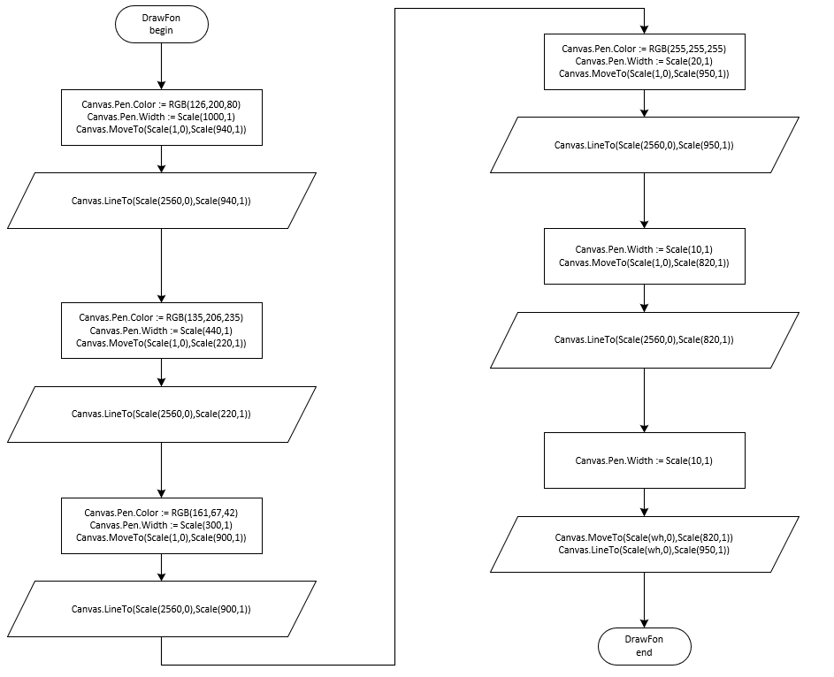

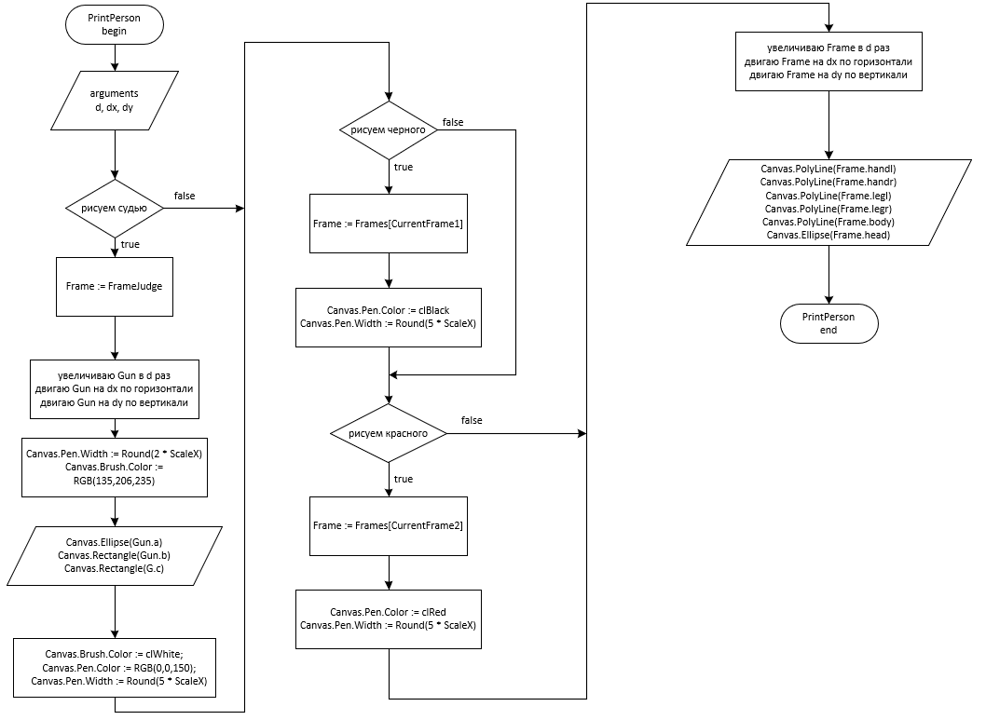

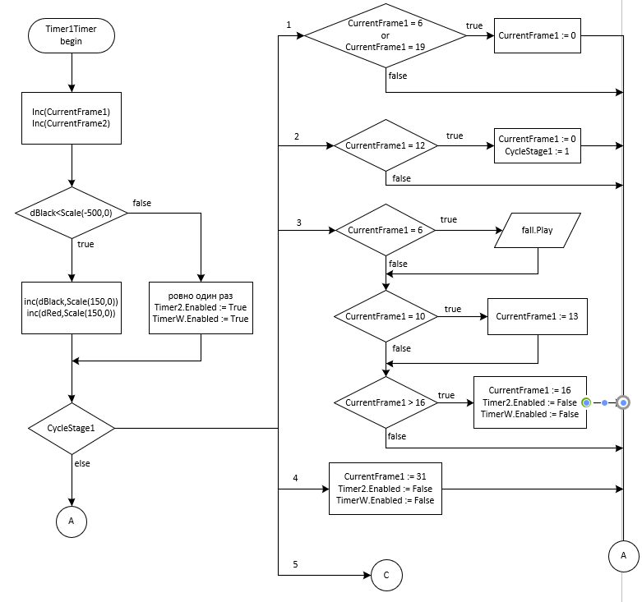

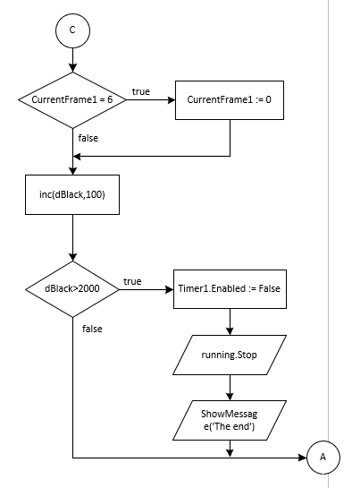

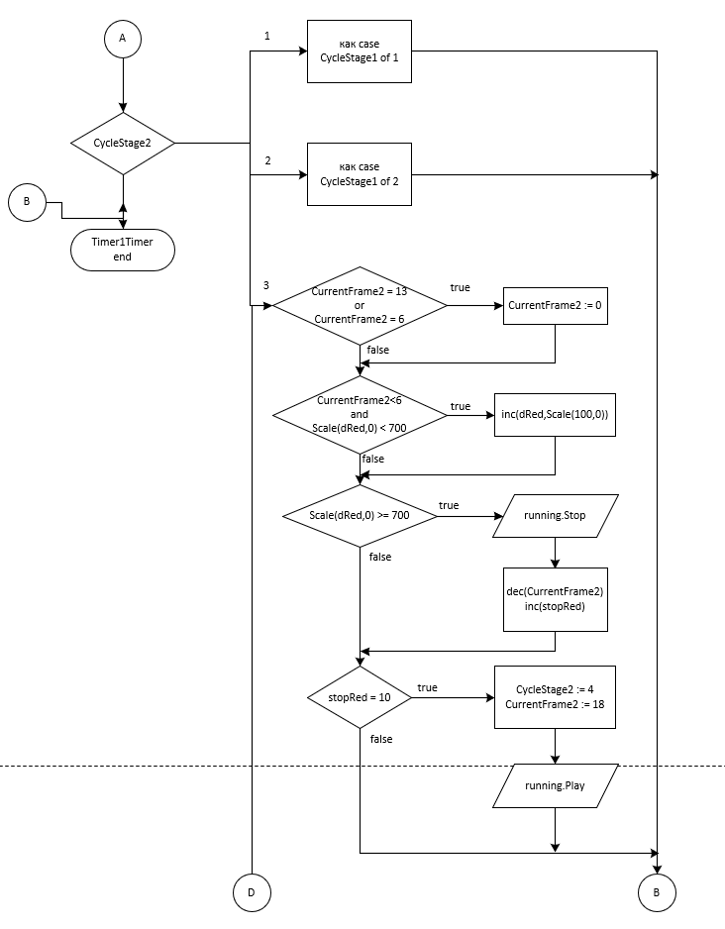

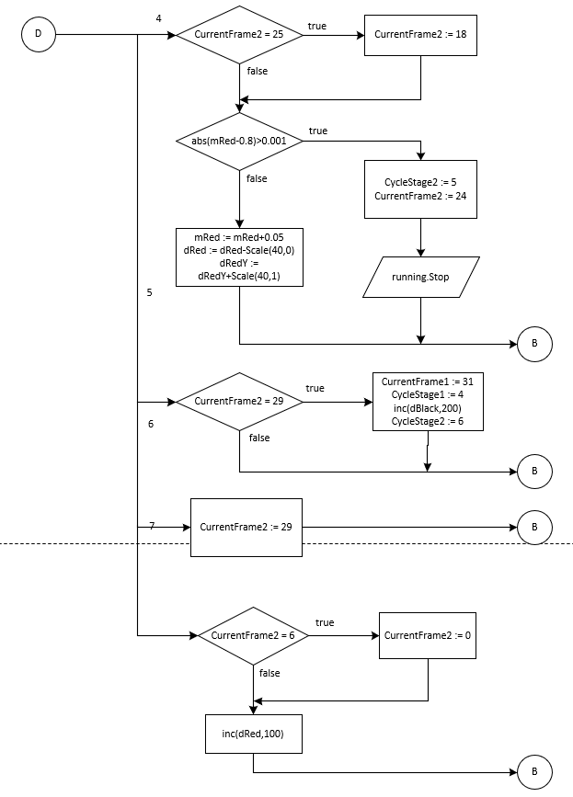

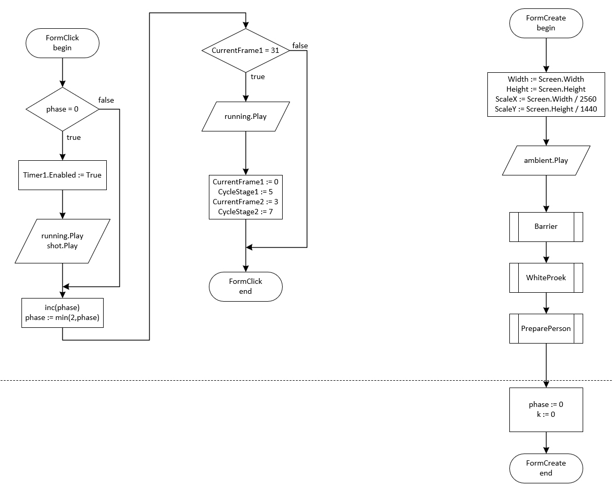

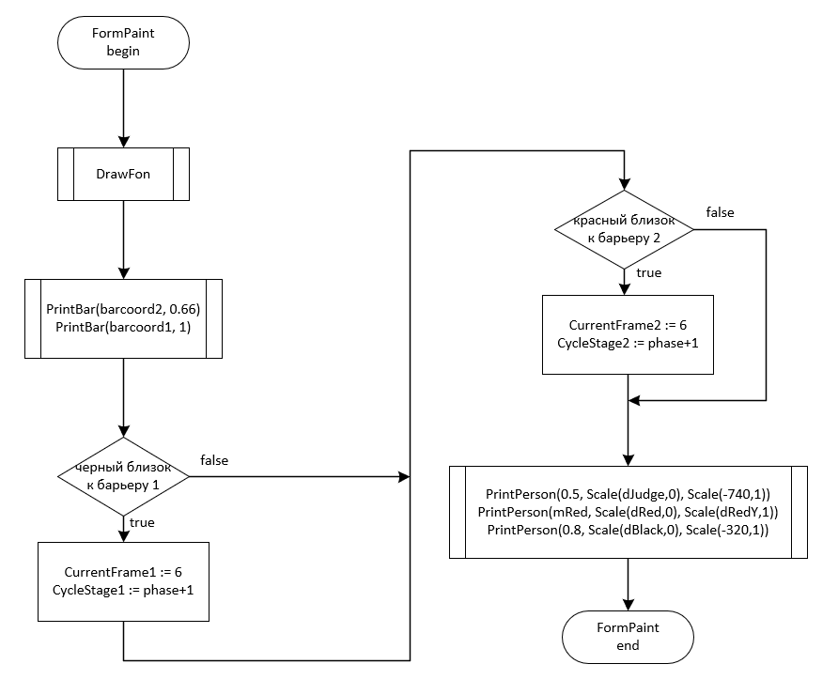
Схема работы программы
Рисунок 3.1 – Схема работы программы
3.2 Определение подпрограмм и их описание
Таблица 3.1 используемые идентификаторы
Имя подпрограммы | Назначение подпрограммы | Заголовок подпрограммы | Имя параметра | Назначение параметра
LoadFrames | Создание кадров с людьми | procedure LoadFrames;
FormCreate | Действия при создании формы | procedure TForm1.FormCreate(Sender: TObject); | Sender | TObject
FormPaint | Перерисовывание окна | procedure TForm1.FormPaint(Sender: TObject); | Sender | TObject
FormClick | Увеличение фазы при клике | procedure TForm1.FormClick(Sender: TObject); | Sender | TObject
Scale | Адаптация мультфильма под любое разрешение экрана | function Scale(c: integer; xy: integer): integer; | c, xy | Выражение, которое надо адаптировать, по какому ширине/высоте надо адаптировать
PrintPerson | Отрисовка кадра с человеком | procedure TForm1.PrintPerson(d: real; dx: integer; dy: integer); | d, dx, dy | Масштаб, смещение по OX, смещение по OY
PreparePerson | Подготовка людей к отрисовке | procedure TForm1.PreparePerson;
Timer1Timer | Движение людей по таймеру | procedure TForm1.Timer1Timer(Sender: TObject); | Sender | TObject
PrintBar | Отрисовка барьера | procedure TForm1.PrintBar(p: TPoint; size: real); | p, size | Левый нижний пиксель, масштаб
Barrier | Подготовка барьеров к отрисовке | procedure TForm1.Barrier;
Timer2Timer | Линейное движение фона | procedure TForm1.Timer2Timer(Sender: TObject); | Sender | TObject
WhiteProek | Подготовка разметки стадиона к отрисовке | procedure TForm1.WhiteProek;
TimerWTimer | Движение разметки стадиона | procedure TForm1.TimerWTimer(Sender: TObject); | Sender | TObject
DrawFon | Отрисовка фона | procedure TForm1.DrawFon;
  - Выделение основных структур данных
Таблица 3.1 используемые идентификаторы
Имя идентификатора структуры | Назначение структуры | Тип структуры
TFrameInfo | Поза человека. Состоит из 4 конечностей, туловища, головы, максимальных координат по x и y. | record  handl, handr, legl, legr: array [1..3] of TPoint;  body: array [1..2] of TPoint;  head: TRect;  pmax: TPoint;
Frames | Все позы людей | array of TFrameInfo
TGun | Пистолет судьи | record  a, b, c: TRect;

3.5 Тестирование и отладка программы
Таблица 3.2 Прохождение тестов программы
Номер теста | Вводимые данные | Ожидаемый результат | Полученный результат
1 | 2 клика | Все работает | Все работает
2 | 1 клик | Бесконечный бег, музыка заканчивается | Бесконечный бег, музыка заканчивается
3 | Много кликов | Все работает | Все работает
4 | Не кликать | Без движения, музыка заканчивается | Без движения, музыка заканчивается
Анализ прохождения тестов, причины возникших ошибок, внесение изменений в алгоритм и текст программы
3.6 Итоговый текст программы с комментариями
unit Unit1;

interface

uses
Winapi.Windows, Winapi.Messages, System.SysUtils, System.Variants, System.Classes,
System.UItypes, Vcl.Graphics, Vcl.Controls, Vcl.Forms, Vcl.Dialogs, Vcl.ExtCtrls,
Person, Vcl.MPlayer;

type
TForm1 = class(TForm)
ambient, shot, fall, running: TMediaPlayer;
procedure FormCreate(Sender: TObject);
procedure FormPaint(Sender: TObject);
procedure PrintPerson(d: real; dx: integer; dy: integer);
procedure PreparePerson;
procedure PrintBar(p: TPoint; size: real);
procedure Barrier;
procedure Timer2Timer(Sender: TObject);
procedure WhiteProek;
procedure TimerWTimer(Sender: TObject);
procedure Timer1Timer(Sender: TObject);
procedure DrawFon;
procedure FormClick(Sender: TObject);
private
public
end;

var
Form1: TForm1;
Frames: array of TFrameInfo;
FrameJudge: TFrameInfo;
Gun: TGun;
CurrentFrame1, CycleStage1: Integer;
CurrentFrame2, CycleStage2: Integer;
phase, dBlack, dRed, dJudge: Integer;
dRedY, stopRed, k: integer;
mRed: real;
Timer1, Timer2, TimerW: TTimer;
ScaleX, ScaleY: extended;
Person1XY, Person2XY: TPoint;
barcoord1, barcoord2: TPoint;
wh: array[1..8]of real;

implementation
{$R *.dfm}

function Scale(c: integer; xy: integer): integer;
begin
if (xy=0) then
Result := Round(c*ScaleX)
else
Result := Round(c*ScaleY);
end;

procedure TForm1.PrintBar(p: TPoint; size: real);
begin
Canvas.Pen.Color := RGB(80,80,80);
Canvas.Pen.Width := Scale(Round(15*size),1);
Canvas.MoveTo(Scale(p.X,0),Scale(p.Y,1));
Canvas.LineTo(Scale(p.X,0), Scale(Round(p.Y - 300*size),1));
Canvas.LineTo(Scale(Round(p.X + 70*size),0), Scale(Round(p.Y - 300*size),1));
Canvas.MoveTo(Scale(p.X,0), Scale(p.Y,1));
Canvas.LineTo(Scale(Round(p.X + 200*size),0), Scale(p.Y,1));
end;

procedure TForm1.Barrier;
begin
Timer2 := TTimer.Create(Self);
Timer2.Interval := 10;
Timer2.OnTimer := Timer2Timer;
Timer2.Enabled := False;
barcoord1 := Point(1700,1000);
barcoord2 := Point(2440,775);
end;

procedure TForm1.Timer2Timer(Sender: TObject);
begin
dec(barcoord1.x,20);
if barcoord1.x <= -200 then
barcoord1.x := 2560;
dec(barcoord2.x,20);
if barcoord2.x <= -200 then
barcoord2.x := 2560;
dec(dJudge,20);
Invalidate;
end;

procedure TForm1.WhiteProek;
begin
TimerW := TTimer.Create(Self);
TimerW.Interval := 1;
TimerW.OnTimer := TimerWTimer;
TimerW.Enabled := False;
wh[1] := 2400;
wh[2] := 2560;
wh[3] := 1280;
wh[4] := 1280;
wh[5] := 160+2240*3 div 4;
wh[6] := 2560*3 div 4;
wh[7] := 160+2240 div 4;
wh[8] := 2560 div 4;
end;

procedure TForm1.TimerWTimer(Sender: TObject);
var
i: integer;
begin
for i := 1 to 4 do begin
wh[2*i-1] := wh[2*i-1]- 20*224 div 256;
wh[2*i] := wh[2*i]-20;
if (wh[2*i]<=0) then begin
wh[2*i-1] := 2400;
wh[2*i] := 2560;
end;
end;
Invalidate;
end;

procedure TForm1.DrawFon;
var
i: integer;
begin
Canvas.Pen.Color := RGB(126,200,80);
Canvas.Pen.Width := Scale(1000,1);
Canvas.MoveTo(Scale(1,0),Scale(940,1));
Canvas.LineTo(Scale(2560,0),Scale(940,1));

Canvas.Pen.Color := RGB(135,206,235);
Canvas.Pen.Width := Scale(440,1);
Canvas.MoveTo(Scale(1,0),Scale(220,1));
Canvas.LineTo(Scale(2560,0),Scale(220,1));

Canvas.Pen.Color := RGB(161,67,42);
Canvas.Pen.Width := Scale(300,1);
Canvas.MoveTo(Scale(1,0),Scale(900,1));
Canvas.LineTo(Scale(2560,0),Scale(900,1));

Canvas.Pen.Color := RGB(255,255,255);
Canvas.Pen.Width := Scale(20,1);
Canvas.MoveTo(Scale(1,0),Scale(950,1));
Canvas.LineTo(Scale(2560,0),Scale(950,1));

Canvas.Pen.Width := Scale(10,1);
Canvas.MoveTo(Scale(1,0),Scale(820,1));
Canvas.LineTo(Scale(2560,0),Scale(820,1));

Canvas.Pen.Width := Scale(10,1);
for i := 1 to 4 do begin
Canvas.MoveTo(Scale(Round(wh[2*i-1]),0),Scale(820,1));
Canvas.LineTo(Scale(Round(wh[2*i]),0),Scale(950,1));
end;
end;

procedure TForm1.PrintPerson(d: real; dx: integer; dy: integer);
var
i: integer;
Frame: TFrameInfo;
G: TGun;
begin
d := (1-d);
if (dy=Scale(-740,1)) then begin
Frame := FrameJudge;
G := Gun;

Canvas.Pen.Width := Round(2 * ScaleX);
Canvas.Brush.Color := RGB(135,206,235);
inc(G.a.left, Round(d*(Frame.pmax.X-G.a.left)));
inc(G.a.top, Round(d*(Frame.pmax.Y-G.a.top)));
inc(G.a.right, Round(d*(Frame.pmax.X-G.a.right)));
inc(G.a.bottom, Round(d*(Frame.pmax.Y-G.a.bottom)));
inc(G.a.left,dx);inc(G.a.right,dx);inc(G.a.top,dy);inc(G.a.bottom,dy);
Canvas.Ellipse(G.a);

Canvas.Pen.Width := Round(5 * ScaleX);
Canvas.Brush.Color := clBLack;
inc(G.b.left, Round(d*(Frame.pmax.X-G.b.left)));
inc(G.b.top, Round(d*(Frame.pmax.Y-G.b.top)));
inc(G.b.right, Round(d*(Frame.pmax.X-G.b.right)));
inc(G.b.bottom, Round(d*(Frame.pmax.Y-G.b.bottom)));
inc(G.b.left,dx);inc(G.b.right,dx);inc(G.b.top,dy);inc(G.b.bottom,dy);
Canvas.Rectangle(G.b);

inc(G.c.left, Round(d*(Frame.pmax.X-G.c.left)));
inc(G.c.top, Round(d*(Frame.pmax.Y-G.c.top)));
inc(G.c.right, Round(d*(Frame.pmax.X-G.c.right)));
inc(G.c.bottom, Round(d*(Frame.pmax.Y-G.c.bottom)));
inc(G.c.left,dx);inc(G.c.right,dx);inc(G.c.top,dy);inc(G.c.bottom,dy);
Canvas.Rectangle(G.c);

Canvas.Brush.Color := clWhite;
Canvas.Pen.Color := RGB(0,0,150);
Canvas.Pen.Width := Round(5 * ScaleX);
end;
if (dy=Scale(-320,1)) then begin
Frame := Frames[CurrentFrame1];
Canvas.Pen.Color := clBlack;
Canvas.Pen.Width := Round(5 * ScaleX);
end;
if (dy=Scale(dRedY,1)) then begin
Frame := Frames[CurrentFrame2];
Canvas.Pen.Color := clRed;
Canvas.Pen.Width := Round(5 * ScaleX);
end;

for i := 1 to 3 do begin
inc(Frame.handl[i].X, Round(d*(Frame.pmax.X-Frame.handl[i].X)));
inc(Frame.handl[i].Y, Round(d*(Frame.pmax.Y-Frame.handl[i].Y)));
inc(Frame.handr[i].X, Round(d*(Frame.pmax.X-Frame.handr[i].X)));
inc(Frame.handr[i].Y, Round(d*(Frame.pmax.Y-Frame.handr[i].Y)));
inc(Frame.legl[i].X, Round(d*(Frame.pmax.X-Frame.legl[i].X)));
inc(Frame.legl[i].Y, Round(d*(Frame.pmax.Y-Frame.legl[i].Y)));
inc(Frame.legr[i].X, Round(d*(Frame.pmax.X-Frame.legr[i].X)));
inc(Frame.legr[i].Y, Round(d*(Frame.pmax.Y-Frame.legr[i].Y)));
if (i<3) then begin
inc(Frame.body[i].X, Round(d*(Frame.pmax.X-Frame.body[i].X)));
inc(Frame.body[i].Y, Round(d*(Frame.pmax.Y-Frame.body[i].Y)));
end;
end;
inc(Frame.head.left, Round(d*(Frame.pmax.X-Frame.head.left)));
inc(Frame.head.top, Round(d*(Frame.pmax.Y-Frame.head.top)));
inc(Frame.head.right, Round(d*(Frame.pmax.X-Frame.head.right)));
inc(Frame.head.bottom, Round(d*(Frame.pmax.Y-Frame.head.bottom)));

for i := 1 to 3 do begin
inc(Frame.handl[i].X,dx);
inc(Frame.handl[i].Y,dy);
inc(Frame.handr[i].X,dx);
inc(Frame.handr[i].Y,dy);
inc(Frame.legl[i].X,dx);
inc(Frame.legl[i].Y,dy);
inc(Frame.legr[i].X,dx);
inc(Frame.legr[i].Y,dy);
if (i<3) then begin
inc(Frame.body[i].X,dx);
inc(Frame.body[i].Y,dy);
end;
end;
inc(Frame.head.left,dx);
inc(Frame.head.top,dy);
Frame.head.width := Frame.head.width+dx;
Frame.head.height := Frame.head.height+dy;

Canvas.PolyLine(Frame.handl);
Canvas.PolyLine(Frame.handr);
Canvas.PolyLine(Frame.legl);
Canvas.PolyLine(Frame.legr);
Canvas.PolyLine(Frame.body);
Canvas.Ellipse(Frame.head);
end;

procedure TForm1.PreparePerson;
begin
Person.LoadFrames;
CurrentFrame1 := 17;
CurrentFrame2 := 17;
Timer1 := TTimer.Create(Self);
Timer1.Interval := 90;
Timer1.OnTimer := Timer1Timer;
Timer1.Enabled := False;
CycleStage1 := 1;
CycleStage2 := 1;
dBlack := Scale(-1000,0);
dRed := Scale(-500,0);
dJudge := Scale(-500,0);
mRed := 0.5;
dRedY := Scale(-550,1);
stopRed := 0;
end;

procedure TForm1.Timer1Timer(Sender: TObject);
begin
Inc(CurrentFrame1);
Inc(CurrentFrame2);
if (dBlack<Scale(-500,0)) then begin
inc(dBlack,Scale(150,0));
inc(dRed,Scale(150,0));
end
else begin
if k = 0 then begin
Timer2.Enabled := True;
TimerW.Enabled := True;
end;
k := 1;
end;

case CycleStage1 of
1: begin
if CurrentFrame1 = 6 then
CurrentFrame1 := 0;
if CurrentFrame1 = 19 then
CurrentFrame1 := 0;
end;

2: begin
if CurrentFrame1 > 12 then begin
CurrentFrame1 := 0;
CycleStage1 := 1;
end;
end;

3: begin
if CurrentFrame1 = 6 then
fall.Play;
if CurrentFrame1 = 10 then
CurrentFrame1 := 13;
if CurrentFrame1 > 16 then begin
CurrentFrame1 := 16;
Timer2.Enabled := False;
TimerW.Enabled := False;
end;
end;

4: begin
CurrentFrame1 := 31;
Timer2.Enabled := False;
TimerW.Enabled := False;
end;

5: begin
if CurrentFrame1 = 6 then
CurrentFrame1 := 0;
inc(dBlack,100);
if dBlack>2000 then begin
Timer1.Enabled := False;
running.Stop;
ShowMessage('The end');
end;
end;
end;

case CycleStage2 of
1: begin
if CurrentFrame2 = 6 then
CurrentFrame2 := 0;
if CurrentFrame2 = 19 then
CurrentFrame2 := 3;
end;

2: begin
if CurrentFrame2 = 13 then begin
CurrentFrame2 := 0;
CycleStage2 := 1;
end;
end;

3: begin
if CurrentFrame2 = 13 then
CurrentFrame2 := 0;
if CurrentFrame2 = 6 then
CurrentFrame2 := 0;
if (CurrentFrame2<6) and (Scale(dRed,0) < Scale(700,0)) then
inc(dRed,Scale(100,0));
if (Scale(dRed,0) >= Scale(700,0)) then begin
running.Stop;
CurrentFrame2 := CurrentFrame2-1;
inc(stopRed);
end;
if stopRed = 10 then begin
CycleStage2 := 4;
CurrentFrame2 := 18;
running.Play;
end;
end;

4: begin
if CurrentFrame2 = 25 then
CurrentFrame2 := 18;
if (abs(mRed-0.8)>0.001) then begin
mRed := mRed+0.05;
dRed := dRed-Scale(40,0);
dRedY := dRedY+Scale(40,1);
end
else begin
CycleStage2 := 5;
CurrentFrame2 := 24;
running.Stop;
end;
end;

5: begin
if CurrentFrame2 = 28 then begin
CurrentFrame1 := 30;
inc(dBlack,300);
end;
if CurrentFrame2 = 29 then begin
CurrentFrame1 := 31;
CycleStage1 := 4;
inc(dBlack,200);
CycleStage2 := 6;
end;
end;

6: begin
CurrentFrame2 := 29;
end;

7: begin
if CurrentFrame2 = 6 then
CurrentFrame2 := 0;
inc(dRed,100);
end;
end;
Invalidate;
end;

procedure TForm1.FormClick(Sender: TObject);
begin
if phase = 0 then begin
Timer1.Enabled := True;
running.Play;
shot.Play;
end;
inc(phase);
if phase > 2 then
phase := 2;
if CurrentFrame1 = 31 then begin
running.Play;
CurrentFrame1 := 0;
CycleStage1 := 5;
CurrentFrame2 := 3;
CycleStage2 := 7;
end;
end;

procedure TForm1.FormCreate(Sender: TObject);
begin
//BorderStyle := bsNone;
WindowState := wsMaximized;
Left := 0;
Top := 0;
Width := Screen.Width;
Height := Screen.Height;
ScaleX := Screen.Width / 2560;
ScaleY := Screen.Height / 1440;

ambient.Open;
ambient.Play;
shot.Open;
fall.Open;
running.Open;

Barrier;
WhiteProek;
PreparePerson;
phase := 0;
k := 0;
end;

procedure TForm1.FormPaint(Sender: TObject);
begin
DrawFon;
PrintBar(barcoord2, 0.66);
PrintBar(barcoord1, 1);
if (Scale(barcoord1.x,0)-Scale(250, 0)-(Frames[CurrentFrame1].pmax.X+Scale(dBlack,0))>=Scale(-10,0))
and(Scale(barcoord1.x,0)-Scale(250, 0)-(Frames[CurrentFrame1].pmax.X+Scale(dBlack,0))<Scale(10,0)) then begin
CurrentFrame1 := 6;
CycleStage1 := phase+1;
end;
if (Scale(barcoord2.x,0)-Scale(250, 0)-(Frames[CurrentFrame2].pmax.X+Scale(dRed,0))>=Scale(-10,0))
and(Scale(barcoord2.x,0)-Scale(250, 0)-(Frames[CurrentFrame2].pmax.X+Scale(dRed,0))<Scale(10,0)) then begin
CurrentFrame2 := 6;
CycleStage2 := phase+1;
end;
PrintPerson(0.5, Scale(dJudge,0), Scale(-740,1));
PrintPerson(mRed, Scale(dRed,0), Scale(dRedY,1));
PrintPerson(0.8, Scale(dBlack,0), Scale(-320,1));
end;

end.

unit Person;
interface

uses
Types, Dialogs, Sysutils;

type
TFrameInfo = record
handl, handr, legl, legr: array [1..3] of TPoint;
body: array [1..2] of TPoint;
head: TRect;
pmax: TPoint;
end;

TGun = record
a, b, c: TRect;
end;

procedure LoadFrames;

implementation

uses Unit1;

procedure LoadFrames;
begin

FrameJudge.handl[1] := Point(Round(580 * ScaleX), Round(690 * ScaleY));
FrameJudge.handl[2] := Point(Round(520 * ScaleX), Round(850 * ScaleY));
FrameJudge.handl[3] := Point(Round(520 * ScaleX), Round(1000 * ScaleY));

FrameJudge.handr[1] := Point(Round(580 * ScaleX), Round(690 * ScaleY));
FrameJudge.handr[2] := Point(Round(715 * ScaleX), Round(540 * ScaleY));
FrameJudge.handr[3] := Point(Round(715 * ScaleX), Round(385 * ScaleY));

FrameJudge.legl[1] := Point(Round(580 * ScaleX), Round(1000 * ScaleY));
FrameJudge.legl[2] := Point(Round(520 * ScaleX), Round(1180 * ScaleY));
FrameJudge.legl[3] := Point(Round(520 * ScaleX), Round(1340 * ScaleY));

FrameJudge.legr[1] := Point(Round(580 * ScaleX), Round(1000 * ScaleY));
FrameJudge.legr[2] := Point(Round(640 * ScaleX), Round(1180 * ScaleY));
FrameJudge.legr[3] := Point(Round(640 * ScaleX), Round(1340 * ScaleY));

FrameJudge.head := Rect(Round(510 * ScaleX), Round(640 * ScaleY), Round(650 * ScaleX), Round(500 * ScaleY));
FrameJudge.body[1] := Point(Round(580 * ScaleX), Round(1000 * ScaleY));
FrameJudge.body[2] := Point(Round(580 * ScaleX), Round(540 * ScaleY));

FrameJudge.pmax := Point(Round(740 * ScaleX), Round(1340 * ScaleY));

Gun.a := Rect(Round(712 * ScaleX), Round(362 * ScaleY), Round(728 * ScaleX), Round(378 * ScaleY));
Gun.b := Rect(Round(700 * ScaleX), Round(330 * ScaleY), Round(715 * ScaleX), Round(385 * ScaleY));
Gun.c := Rect(Round(715 * ScaleX), Round(375 * ScaleY), Round(740 * ScaleX), Round(385 * ScaleY));

SetLength(Frames, 32);

//running
Frames[0].handl[1] := Point(Round(1350 * ScaleX), Round(690 * ScaleY));
Frames[0].handl[2] := Point(Round(1190 * ScaleX), Round(700 * ScaleY));
Frames[0].handl[3] := Point(Round(1185 * ScaleX), Round(830 * ScaleY));

Frames[0].handr[1] := Point(Round(1350 * ScaleX), Round(690 * ScaleY));
Frames[0].handr[2] := Point(Round(1530 * ScaleX), Round(750 * ScaleY));
Frames[0].handr[3] := Point(Round(1575 * ScaleX), Round(595 * ScaleY));

Frames[0].legl[1] := Point(Round(1280 * ScaleX), Round(1000 * ScaleY));
Frames[0].legl[2] := Point(Round(1220 * ScaleX), Round(1180 * ScaleY));
Frames[0].legl[3] := Point(Round(1010 * ScaleX), Round(1240 * ScaleY));

Frames[0].legr[1] := Point(Round(1280 * ScaleX), Round(1000 * ScaleY));
Frames[0].legr[2] := Point(Round(1450 * ScaleX), Round(1130 * ScaleY));
Frames[0].legr[3] := Point(Round(1400 * ScaleX), Round(1290 * ScaleY));

Frames[0].head := Rect(Round(1300 * ScaleX), Round(640 * ScaleY), Round(1440 * ScaleX), Round(500 * ScaleY));
Frames[0].body[1] := Point(Round(1280 * ScaleX), Round(1000 * ScaleY));
Frames[0].body[2] := Point(Round(1380 * ScaleX), Round(540 * ScaleY));

Frames[0].pmax := Point(Round(1575 * ScaleX), Round(1290 * ScaleY));

Frames[1].handl[1] := Point(Round(1350 * ScaleX), Round(690 * ScaleY));
Frames[1].handl[2] := Point(Round(1190 * ScaleX), Round(810 * ScaleY));
Frames[1].handl[3] := Point(Round(1300 * ScaleX), Round(917 * ScaleY));

Frames[1].handr[1] := Point(Round(1350 * ScaleX), Round(690 * ScaleY));
Frames[1].handr[2] := Point(Round(1380 * ScaleX), Round(874 * ScaleY));
Frames[1].handr[3] := Point(Round(1520 * ScaleX), Round(864 * ScaleY));

Frames[1].legl[1] := Point(Round(1280 * ScaleX), Round(1000 * ScaleY));
Frames[1].legl[2] := Point(Round(1280 * ScaleX), Round(1190 * ScaleY));
Frames[1].legl[3] := Point(Round(1110 * ScaleX), Round(1130 * ScaleY));

Frames[1].legr[1] := Point(Round(1280 * ScaleX), Round(1000 * ScaleY));
Frames[1].legr[2] := Point(Round(1420 * ScaleX), Round(1180 * ScaleY));
Frames[1].legr[3] := Point(Round(1420 * ScaleX), Round(1340 * ScaleY));

Frames[1].head := Rect(Round(1300 * ScaleX), Round(640 * ScaleY), Round(1440 * ScaleX), Round(500 * ScaleY));
Frames[1].body[1] := Point(Round(1280 * ScaleX), Round(1000 * ScaleY));
Frames[1].body[2] := Point(Round(1380 * ScaleX), Round(540 * ScaleY));

Frames[1].pmax := Point(Round(1520 * ScaleX), Round(1340 * ScaleY));

Frames[2].handl[1] := Point(Round(1350 * ScaleX), Round(690 * ScaleY));
Frames[2].handl[2] := Point(Round(1250 * ScaleX), Round(850 * ScaleY));
Frames[2].handl[3] := Point(Round(1380 * ScaleX), Round(870 * ScaleY));

Frames[2].handr[1] := Point(Round(1350 * ScaleX), Round(690 * ScaleY));
Frames[2].handr[2] := Point(Round(1350 * ScaleX), Round(864 * ScaleY));
Frames[2].handr[3] := Point(Round(1500 * ScaleX), Round(870 * ScaleY));

Frames[2].legl[1] := Point(Round(1280 * ScaleX), Round(1000 * ScaleY));
Frames[2].legl[2] := Point(Round(1310 * ScaleX), Round(1150 * ScaleY));
Frames[2].legl[3] := Point(Round(1150 * ScaleX), Round(1120 * ScaleY));

Frames[2].legr[1] := Point(Round(1280 * ScaleX), Round(1000 * ScaleY));
Frames[2].legr[2] := Point(Round(1370 * ScaleX), Round(1180 * ScaleY));
Frames[2].legr[3] := Point(Round(1300 * ScaleX), Round(1340 * ScaleY));

Frames[2].head := Rect(Round(1300 * ScaleX), Round(640 * ScaleY), Round(1440 * ScaleX), Round(500 * ScaleY));
Frames[2].body[1] := Point(Round(1280 * ScaleX), Round(1000 * ScaleY));
Frames[2].body[2] := Point(Round(1380 * ScaleX), Round(540 * ScaleY));

Frames[2].pmax := Point(Round(1500 * ScaleX), Round(1340 * ScaleY));

Frames[3].handl[1] := Point(Round(1350 * ScaleX), Round(690 * ScaleY));
Frames[3].handl[2] := Point(Round(1190 * ScaleX), Round(770 * ScaleY));
Frames[3].handl[3] := Point(Round(1290 * ScaleX), Round(880 * ScaleY));

Frames[3].handr[1] := Point(Round(1350 * ScaleX), Round(690 * ScaleY));
Frames[3].handr[2] := Point(Round(1440 * ScaleX), Round(840 * ScaleY));
Frames[3].handr[3] := Point(Round(1560 * ScaleX), Round(745 * ScaleY));

Frames[3].legl[1] := Point(Round(1280 * ScaleX), Round(1000 * ScaleY));
Frames[3].legl[2] := Point(Round(1420 * ScaleX), Round(1080 * ScaleY));
Frames[3].legl[3] := Point(Round(1240 * ScaleX), Round(1170 * ScaleY));

Frames[3].legr[1] := Point(Round(1280 * ScaleX), Round(1000 * ScaleY));
Frames[3].legr[2] := Point(Round(1320 * ScaleX), Round(1220 * ScaleY));
Frames[3].legr[3] := Point(Round(1210 * ScaleX), Round(1340 * ScaleY));

Frames[3].head := Rect(Round(1300 * ScaleX), Round(640 * ScaleY), Round(1440 * ScaleX), Round(500 * ScaleY));
Frames[3].body[1] := Point(Round(1280 * ScaleX), Round(1000 * ScaleY));
Frames[3].body[2] := Point(Round(1380 * ScaleX), Round(540 * ScaleY));

Frames[3].pmax := Point(Round(1560 * ScaleX), Round(1340 * ScaleY));

Frames[4].handl[1] := Point(Round(1350 * ScaleX), Round(690 * ScaleY));
Frames[4].handl[2] := Point(Round(1170 * ScaleX), Round(750 * ScaleY));
Frames[4].handl[3] := Point(Round(1270 * ScaleX), Round(880 * ScaleY));

Frames[4].handr[1] := Point(Round(1350 * ScaleX), Round(690 * ScaleY));
Frames[4].handr[2] := Point(Round(1460 * ScaleX), Round(820 * ScaleY));
Frames[4].handr[3] := Point(Round(1565 * ScaleX), Round(725 * ScaleY));

Frames[4].legl[1] := Point(Round(1280 * ScaleX), Round(1000 * ScaleY));
Frames[4].legl[2] := Point(Round(1460 * ScaleX), Round(1080 * ScaleY));
Frames[4].legl[3] := Point(Round(1240 * ScaleX), Round(1210 * ScaleY));

Frames[4].legr[1] := Point(Round(1280 * ScaleX), Round(1000 * ScaleY));
Frames[4].legr[2] := Point(Round(1320 * ScaleX), Round(1200 * ScaleY));
Frames[4].legr[3] := Point(Round(1150 * ScaleX), Round(1340 * ScaleY));

Frames[4].head := Rect(Round(1300 * ScaleX), Round(640 * ScaleY), Round(1440 * ScaleX), Round(500 * ScaleY));
Frames[4].body[1] := Point(Round(1280 * ScaleX), Round(1000 * ScaleY));
Frames[4].body[2] := Point(Round(1380 * ScaleX), Round(540 * ScaleY));

Frames[4].pmax := Point(Round(1565 * ScaleX), Round(1340 * ScaleY));

Frames[5].handl[1] := Point(Round(1350 * ScaleX), Round(690 * ScaleY));
Frames[5].handl[2] := Point(Round(1190 * ScaleX), Round(760 * ScaleY));
Frames[5].handl[3] := Point(Round(1240 * ScaleX), Round(867 * ScaleY));

Frames[5].handr[1] := Point(Round(1350 * ScaleX), Round(690 * ScaleY));
Frames[5].handr[2] := Point(Round(1530 * ScaleX), Round(760 * ScaleY));
Frames[5].handr[3] := Point(Round(1570 * ScaleX), Round(620 * ScaleY));

Frames[5].legl[1] := Point(Round(1280 * ScaleX), Round(1000 * ScaleY));
Frames[5].legl[2] := Point(Round(1470 * ScaleX), Round(1130 * ScaleY));
Frames[5].legl[3] := Point(Round(1380 * ScaleX), Round(1250 * ScaleY));

Frames[5].legr[1] := Point(Round(1280 * ScaleX), Round(1000 * ScaleY));
Frames[5].legr[2] := Point(Round(1180 * ScaleX), Round(1200 * ScaleY));
Frames[5].legr[3] := Point(Round(1040 * ScaleX), Round(1340 * ScaleY));

Frames[5].head := Rect(Round(1300 * ScaleX), Round(500 * ScaleY), Round(1440 * ScaleX), Round(640 * ScaleY));
Frames[5].body[1] := Point(Round(1280 * ScaleX), Round(1000 * ScaleY));
Frames[5].body[2] := Point(Round(1380 * ScaleX), Round(540 * ScaleY));

Frames[5].pmax := Point(Round(1570 * ScaleX), Round(1340 * ScaleY));

//jump
Frames[6].handl[1] := Point(Round(1350 * ScaleX), Round(690 * ScaleY));
Frames[6].handl[2] := Point(Round(1200 * ScaleX), Round(800 * ScaleY));
Frames[6].handl[3] := Point(Round(1290 * ScaleX), Round(920 * ScaleY));

Frames[6].handr[1] := Point(Round(1350 * ScaleX), Round(690 * ScaleY));
Frames[6].handr[2] := Point(Round(1540 * ScaleX), Round(750 * ScaleY));
Frames[6].handr[3] := Point(Round(1630 * ScaleX), Round(610 * ScaleY));

Frames[6].legl[1] := Point(Round(1280 * ScaleX), Round(1000 * ScaleY));
Frames[6].legl[2] := Point(Round(1200 * ScaleX), Round(1150 * ScaleY));
Frames[6].legl[3] := Point(Round(1060 * ScaleX), Round(1340 * ScaleY));

Frames[6].legr[1] := Point(Round(1280 * ScaleX), Round(1000 * ScaleY));
Frames[6].legr[2] := Point(Round(1500 * ScaleX), Round(1060 * ScaleY));
Frames[6].legr[3] := Point(Round(1420 * ScaleX), Round(1240 * ScaleY));

Frames[6].head := Rect(Round(1300 * ScaleX), Round(640 * ScaleY), Round(1440 * ScaleX), Round(500 * ScaleY));
Frames[6].body[1] := Point(Round(1280 * ScaleX), Round(1000 * ScaleY));
Frames[6].body[2] := Point(Round(1380 * ScaleX), Round(540 * ScaleY));

Frames[6].pmax := Point(Round(1630 * ScaleX), Round(1340 * ScaleY));

Frames[7].handl[1] := Point(Round(1520 * ScaleX), Round(690 * ScaleY));
Frames[7].handl[2] := Point(Round(1300 * ScaleX), Round(700 * ScaleY));
Frames[7].handl[3] := Point(Round(1350 * ScaleX), Round(810 * ScaleY));

Frames[7].handr[1] := Point(Round(1520 * ScaleX), Round(690 * ScaleY));
Frames[7].handr[2] := Point(Round(1730 * ScaleX), Round(750 * ScaleY));
Frames[7].handr[3] := Point(Round(1840 * ScaleX), Round(650 * ScaleY));

Frames[7].legl[1] := Point(Round(1280 * ScaleX), Round(950 * ScaleY));
Frames[7].legl[2] := Point(Round(1240 * ScaleX), Round(1100 * ScaleY));
Frames[7].legl[3] := Point(Round(1070 * ScaleX), Round(1230 * ScaleY));

Frames[7].legr[1] := Point(Round(1280 * ScaleX), Round(950 * ScaleY));
Frames[7].legr[2] := Point(Round(1520 * ScaleX), Round(890 * ScaleY));
Frames[7].legr[3] := Point(Round(1670 * ScaleX), Round(1010 * ScaleY));

Frames[7].head := Rect(Round(1550 * ScaleX), Round(640 * ScaleY), Round(1690 * ScaleX), Round(500 * ScaleY));
Frames[7].body[1] := Point(Round(1280 * ScaleX), Round(950 * ScaleY));
Frames[7].body[2] := Point(Round(1650 * ScaleX), Round(560 * ScaleY));

Frames[7].pmax := Point(Round(1840 * ScaleX), Round(1230 * ScaleY));

Frames[8].handl[1] := Point(Round(1560 * ScaleX), Round(640 * ScaleY));
Frames[8].handl[2] := Point(Round(1690 * ScaleX), Round(680 * ScaleY));
Frames[8].handl[3] := Point(Round(1890 * ScaleX), Round(640 * ScaleY));

Frames[8].handr[1] := Point(Round(1560 * ScaleX), Round(640 * ScaleY));
Frames[8].handr[2] := Point(Round(1690 * ScaleX), Round(700 * ScaleY));
Frames[8].handr[3] := Point(Round(1900 * ScaleX), Round(660 * ScaleY));

Frames[8].legl[1] := Point(Round(1280 * ScaleX), Round(750 * ScaleY));
Frames[8].legl[2] := Point(Round(1180 * ScaleX), Round(880 * ScaleY));
Frames[8].legl[3] := Point(Round(980 * ScaleX), Round(950 * ScaleY));

Frames[8].legr[1] := Point(Round(1280 * ScaleX), Round(750 * ScaleY));
Frames[8].legr[2] := Point(Round(1520 * ScaleX), Round(700 * ScaleY));
Frames[8].legr[3] := Point(Round(1790 * ScaleX), Round(750 * ScaleY));

Frames[8].head := Rect(Round(1680 * ScaleX), Round(610 * ScaleY), Round(1820 * ScaleX), Round(470 * ScaleY));
Frames[8].body[1] := Point(Round(1280 * ScaleX), Round(750 * ScaleY));
Frames[8].body[2] := Point(Round(1750 * ScaleX), Round(560 * ScaleY));

Frames[8].pmax := Point(Round(1900 * ScaleX), Round(950 * ScaleY));

Frames[9].handl[1] := Point(Round(1580 * ScaleX), Round(590 * ScaleY));
Frames[9].handl[2] := Point(Round(1710 * ScaleX), Round(650 * ScaleY));
Frames[9].handl[3] := Point(Round(1860 * ScaleX), Round(590 * ScaleY));

Frames[9].handr[1] := Point(Round(1580 * ScaleX), Round(590 * ScaleY));
Frames[9].handr[2] := Point(Round(1700 * ScaleX), Round(700 * ScaleY));
Frames[9].handr[3] := Point(Round(1820 * ScaleX), Round(760 * ScaleY));

Frames[9].legl[1] := Point(Round(1280 * ScaleX), Round(710 * ScaleY));
Frames[9].legl[2] := Point(Round(1150 * ScaleX), Round(820 * ScaleY));
Frames[9].legl[3] := Point(Round(930 * ScaleX), Round(780 * ScaleY));

Frames[9].legr[1] := Point(Round(1280 * ScaleX), Round(710 * ScaleY));
Frames[9].legr[2] := Point(Round(1500 * ScaleX), Round(770 * ScaleY));
Frames[9].legr[3] := Point(Round(1620 * ScaleX), Round(890 * ScaleY));

Frames[9].head := Rect(Round(1680 * ScaleX), Round(570 * ScaleY), Round(1820 * ScaleX), Round(430 * ScaleY));
Frames[9].body[1] := Point(Round(1280 * ScaleX), Round(710 * ScaleY));
Frames[9].body[2] := Point(Round(1710 * ScaleX), Round(540 * ScaleY));

Frames[9].pmax := Point(Round(1860 * ScaleX), Round(890 * ScaleY));

Frames[10].handl[1] := Point(Round(1630 * ScaleX), Round(640 * ScaleY));
Frames[10].handl[2] := Point(Round(1600 * ScaleX), Round(780 * ScaleY));
Frames[10].handl[3] := Point(Round(1740 * ScaleX), Round(890 * ScaleY));

Frames[10].handr[1] := Point(Round(1630 * ScaleX), Round(640 * ScaleY));
Frames[10].handr[2] := Point(Round(1600 * ScaleX), Round(780 * ScaleY));
Frames[10].handr[3] := Point(Round(1740 * ScaleX), Round(890 * ScaleY));

Frames[10].legl[1] := Point(Round(1280 * ScaleX), Round(780 * ScaleY));
Frames[10].legl[2] := Point(Round(1590 * ScaleX), Round(860 * ScaleY));
Frames[10].legl[3] := Point(Round(1200 * ScaleX), Round(900 * ScaleY));

Frames[10].legr[1] := Point(Round(1280 * ScaleX), Round(780 * ScaleY));
Frames[10].legr[2] := Point(Round(1540 * ScaleX), Round(930 * ScaleY));
Frames[10].legr[3] := Point(Round(1720 * ScaleX), Round(1080 * ScaleY));

Frames[10].head := Rect(Round(1680 * ScaleX), Round(610 * ScaleY), Round(1820 * ScaleX), Round(470 * ScaleY));
Frames[10].body[1] := Point(Round(1280 * ScaleX), Round(780 * ScaleY));
Frames[10].body[2] := Point(Round(1750 * ScaleX), Round(590 * ScaleY));

Frames[10].pmax := Point(Round(1820 * ScaleX), Round(1080 * ScaleY));

Frames[11].handl[1] := Point(Round(1510 * ScaleX), Round(660 * ScaleY));
Frames[11].handl[2] := Point(Round(1480 * ScaleX), Round(790 * ScaleY));
Frames[11].handl[3] := Point(Round(1620 * ScaleX), Round(930 * ScaleY));

Frames[11].handr[1] := Point(Round(1510 * ScaleX), Round(660 * ScaleY));
Frames[11].handr[2] := Point(Round(1480 * ScaleX), Round(790 * ScaleY));
Frames[11].handr[3] := Point(Round(1620 * ScaleX), Round(930 * ScaleY));

Frames[11].legr[1] := Point(Round(1250 * ScaleX), Round(910 * ScaleY));
Frames[11].legr[2] := Point(Round(1500 * ScaleX), Round(870 * ScaleY));
Frames[11].legr[3] := Point(Round(1430 * ScaleX), Round(1080 * ScaleY));

Frames[11].legl[1] := Point(Round(1250 * ScaleX), Round(910 * ScaleY));
Frames[11].legl[2] := Point(Round(1380 * ScaleX), Round(1060 * ScaleY));
Frames[11].legl[3] := Point(Round(1460 * ScaleX), Round(1240 * ScaleY));

Frames[11].head := Rect(Round(1510 * ScaleX), Round(630 * ScaleY), Round(1650 * ScaleX), Round(490 * ScaleY));
Frames[11].body[1] := Point(Round(1250 * ScaleX), Round(910 * ScaleY));
Frames[11].body[2] := Point(Round(1550 * ScaleX), Round(620 * ScaleY));

Frames[11].pmax := Point(Round(1650 * ScaleX), Round(1240 * ScaleY));

Frames[12].handl[1] := Point(Round(1350 * ScaleX), Round(690 * ScaleY));
Frames[12].handl[2] := Point(Round(1200 * ScaleX), Round(800 * ScaleY));
Frames[12].handl[3] := Point(Round(1290 * ScaleX), Round(920 * ScaleY));

Frames[12].handr[1] := Point(Round(1350 * ScaleX), Round(690 * ScaleY));
Frames[12].handr[2] := Point(Round(1540 * ScaleX), Round(750 * ScaleY));
Frames[12].handr[3] := Point(Round(1630 * ScaleX), Round(610 * ScaleY));

Frames[12].legl[1] := Point(Round(1280 * ScaleX), Round(1000 * ScaleY));
Frames[12].legl[2] := Point(Round(1200 * ScaleX), Round(1150 * ScaleY));
Frames[12].legl[3] := Point(Round(1060 * ScaleX), Round(1340 * ScaleY));

Frames[12].legr[1] := Point(Round(1280 * ScaleX), Round(1000 * ScaleY));
Frames[12].legr[2] := Point(Round(1500 * ScaleX), Round(1060 * ScaleY));
Frames[12].legr[3] := Point(Round(1020 * ScaleX), Round(1340 * ScaleY));

Frames[12].head := Rect(Round(1300 * ScaleX), Round(640 * ScaleY), Round(1440 * ScaleX), Round(500 * ScaleY));
Frames[12].body[1] := Point(Round(1280 * ScaleX), Round(1000 * ScaleY));
Frames[12].body[2] := Point(Round(1380 * ScaleX), Round(540 * ScaleY));

Frames[12].pmax := Point(Round(1630 * ScaleX), Round(1340 * ScaleY));

//fall
Frames[13].handl[1] := Point(Round(1630 * ScaleX), Round(640 * ScaleY));
Frames[13].handl[2] := Point(Round(1790 * ScaleX), Round(740 * ScaleY));
Frames[13].handl[3] := Point(Round(1840 * ScaleX), Round(860 * ScaleY));

Frames[13].handr[1] := Point(Round(1630 * ScaleX), Round(640 * ScaleY));
Frames[13].handr[2] := Point(Round(1630 * ScaleX), Round(800 * ScaleY));
Frames[13].handr[3] := Point(Round(1710 * ScaleX), Round(930 * ScaleY));

Frames[13].legl[1] := Point(Round(1280 * ScaleX), Round(780 * ScaleY));
Frames[13].legl[2] := Point(Round(1020 * ScaleX), Round(820 * ScaleY));
Frames[13].legl[3] := Point(Round(810 * ScaleX), Round(780 * ScaleY));

Frames[13].legr[1] := Point(Round(1280 * ScaleX), Round(780 * ScaleY));
Frames[13].legr[2] := Point(Round(1100 * ScaleX), Round(900 * ScaleY));
Frames[13].legr[3] := Point(Round(860 * ScaleX), Round(920 * ScaleY));

Frames[13].body[1] := Point(Round(1280 * ScaleX), Round(780 * ScaleY));
Frames[13].body[2] := Point(Round(1750 * ScaleX), Round(590 * ScaleY));
Frames[13].head := Rect(Round(1680 * ScaleX), Round(610 * ScaleY), Round(1820 * ScaleX), Round(470 * ScaleY));

Frames[13].pmax := Point(Round(1820 * ScaleX), Round(930 * ScaleY));

Frames[14].handl[1] := Point(Round(1680 * ScaleX), Round(740 * ScaleY));
Frames[14].handl[2] := Point(Round(1870 * ScaleX), Round(770 * ScaleY));
Frames[14].handl[3] := Point(Round(1890 * ScaleX), Round(910 * ScaleY));

Frames[14].handr[1] := Point(Round(1680 * ScaleX), Round(740 * ScaleY));
Frames[14].handr[2] := Point(Round(1650 * ScaleX), Round(880 * ScaleY));
Frames[14].handr[3] := Point(Round(1760 * ScaleX), Round(990 * ScaleY));

Frames[14].legl[1] := Point(Round(1330 * ScaleX), Round(880 * ScaleY));
Frames[14].legl[2] := Point(Round(1070 * ScaleX), Round(960 * ScaleY));
Frames[14].legl[3] := Point(Round(860 * ScaleX), Round(880 * ScaleY));

Frames[14].legr[1] := Point(Round(1330 * ScaleX), Round(880 * ScaleY));
Frames[14].legr[2] := Point(Round(1110 * ScaleX), Round(1000 * ScaleY));
Frames[14].legr[3] := Point(Round(910 * ScaleX), Round(950 * ScaleY));

Frames[14].body[1] := Point(Round(1330 * ScaleX), Round(880 * ScaleY));
Frames[14].body[2] := Point(Round(1800 * ScaleX), Round(690 * ScaleY));
Frames[14].head := Rect(Round(1730 * ScaleX), Round(710 * ScaleY), Round(1870 * ScaleX), Round(570 * ScaleY));

Frames[14].pmax := Point(Round(1890 * ScaleX), Round(1000 * ScaleY));

Frames[15].handl[1] := Point(Round(1780 * ScaleX), Round(940 * ScaleY));
Frames[15].handl[2] := Point(Round(1960 * ScaleX), Round(990 * ScaleY));
Frames[15].handl[3] := Point(Round(1990 * ScaleX), Round(1120 * ScaleY));

Frames[15].handr[1] := Point(Round(1780 * ScaleX), Round(940 * ScaleY));
Frames[15].handr[2] := Point(Round(1730 * ScaleX), Round(1100 * ScaleY));
Frames[15].handr[3] := Point(Round(1860 * ScaleX), Round(1190 * ScaleY));

Frames[15].legl[1] := Point(Round(1430 * ScaleX), Round(1080 * ScaleY));
Frames[15].legl[2] := Point(Round(1170 * ScaleX), Round(1120 * ScaleY));
Frames[15].legl[3] := Point(Round(960 * ScaleX), Round(1050 * ScaleY));

Frames[15].legr[1] := Point(Round(1430 * ScaleX), Round(1080 * ScaleY));
Frames[15].legr[2] := Point(Round(1200 * ScaleX), Round(1150 * ScaleY));
Frames[15].legr[3] := Point(Round(1010 * ScaleX), Round(1100 * ScaleY));

Frames[15].body[1] := Point(Round(1430 * ScaleX), Round(1080 * ScaleY));
Frames[15].body[2] := Point(Round(1900 * ScaleX), Round(890 * ScaleY));
Frames[15].head := Rect(Round(1830 * ScaleX), Round(910 * ScaleY), Round(1970 * ScaleX), Round(770 * ScaleY));

Frames[15].pmax := Point(Round(1990 * ScaleX), Round(1190 * ScaleY));

Frames[16].handl[1] := Point(Round(1785 * ScaleX), Round(1180 * ScaleY));
Frames[16].handl[2] := Point(Round(1910 * ScaleX), Round(1250 * ScaleY));
Frames[16].handl[3] := Point(Round(1930 * ScaleX), Round(1340 * ScaleY));

Frames[16].handr[1] := Point(Round(1785 * ScaleX), Round(1180 * ScaleY));
Frames[16].handr[2] := Point(Round(1800 * ScaleX), Round(1290 * ScaleY));
Frames[16].handr[3] := Point(Round(1870 * ScaleX), Round(1340 * ScaleY));

Frames[16].legl[1] := Point(Round(1480 * ScaleX), Round(1240 * ScaleY));
Frames[16].legl[2] := Point(Round(1250 * ScaleX), Round(1340 * ScaleY));
Frames[16].legl[3] := Point(Round(1010 * ScaleX), Round(1250 * ScaleY));

Frames[16].legr[1] := Point(Round(1480 * ScaleX), Round(1240 * ScaleY));
Frames[16].legr[2] := Point(Round(1300 * ScaleX), Round(1340 * ScaleY));
Frames[16].legr[3] := Point(Round(1060 * ScaleX), Round(1240 * ScaleY));

Frames[16].body[1] := Point(Round(1480 * ScaleX), Round(1240 * ScaleY));
Frames[16].body[2] := Point(Round(1965 * ScaleX), Round(1140 * ScaleY));
Frames[16].head := Rect(Round(1880 * ScaleX), Round(1210 * ScaleY), Round(2020 * ScaleX), Round(1070 * ScaleY));

Frames[16].pmax := Point(Round(2020 * ScaleX), Round(1340 * ScaleY));

//low start
Frames[17].handl[1] := Point(Round((282 + 980) * ScaleX), Round(1090 * ScaleY));
Frames[17].handl[2] := Point(Round((300 + 980) * ScaleX), Round(1230 * ScaleY));
Frames[17].handl[3] := Point(Round((320 + 980) * ScaleX), Round(1340 * ScaleY));

Frames[17].handr[1] := Point(Round((282 + 980) * ScaleX), Round(1090 * ScaleY));
Frames[17].handr[2] := Point(Round((300 + 980) * ScaleX), Round(1230 * ScaleY));
Frames[17].handr[3] := Point(Round((320 + 980) * ScaleX), Round(1340 * ScaleY));

Frames[17].legl[1] := Point(Round((30 + 980) * ScaleX), Round(1030 * ScaleY));
Frames[17].legl[2] := Point(Round((159 + 980) * ScaleX), Round(1201 * ScaleY));
Frames[17].legl[3] := Point(Round((30 + 980) * ScaleX), Round(1340 * ScaleY));

Frames[17].legr[1] := Point(Round((30 + 980) * ScaleX), Round(1030 * ScaleY));
Frames[17].legr[2] := Point(Round((130 + 980) * ScaleX), Round(1210 * ScaleY));
Frames[17].legr[3] := Point(Round((10 + 980) * ScaleX), Round(1340 * ScaleY));

Frames[17].head := Rect(Round((331 + 980) * ScaleX), Round(1035 * ScaleY), Round((471 + 980) * ScaleX), Round(1175 * ScaleY));
Frames[17].body[1] := Point(Round((30 + 980) * ScaleX), Round(1030 * ScaleY));
Frames[17].body[2] := Point(Round((331 + 980) * ScaleX), Round(1105 * ScaleY));

Frames[17].pmax := Point(Round((471 + 980) * ScaleX), Round(1340 * ScaleY));

Frames[18].handl[1] := Point(Round((510 + 980) * ScaleX), Round(880 * ScaleY));
Frames[18].handl[2] := Point(Round((630 + 980) * ScaleX), Round(960 * ScaleY));
Frames[18].handl[3] := Point(Round((720 + 980) * ScaleX), Round(850 * ScaleY));

Frames[18].handr[1] := Point(Round((510 + 980) * ScaleX), Round(880 * ScaleY));
Frames[18].handr[2] := Point(Round((350 + 980) * ScaleX), Round(860 * ScaleY));
Frames[18].handr[3] := Point(Round((260 + 980) * ScaleX), Round(980 * ScaleY));

Frames[18].legl[1] := Point(Round((242 + 980) * ScaleX), Round(1080 * ScaleY));
Frames[18].legl[2] := Point(Round((320 + 980) * ScaleX), Round(1203 * ScaleY));
Frames[18].legl[3] := Point(Round((90 + 980) * ScaleX), Round(1250 * ScaleY));

Frames[18].legr[1] := Point(Round((242 + 980) * ScaleX), Round(1080 * ScaleY));
Frames[18].legr[2] := Point(Round((170 + 980) * ScaleX), Round(1240 * ScaleY));
Frames[18].legr[3] := Point(Round((10 + 980) * ScaleX), Round(1340 * ScaleY));

Frames[18].head := Rect(Round((525 + 980) * ScaleX), Round(770 * ScaleY), Round((665 + 980) * ScaleX), Round(910 * ScaleY));
Frames[18].body[1] := Point(Round((242 + 980) * ScaleX), Round(1080 * ScaleY));
Frames[18].body[2] := Point(Round((530 + 980) * ScaleX), Round(870 * ScaleY));

Frames[18].pmax := Point(Round((665 + 980) * ScaleX), Round(1340 * ScaleY));

//reverse running
Frames[19].handl[1] := Point(Round(1235 * ScaleX), Round(690 * ScaleY));
Frames[19].handl[2] := Point(Round(1395 * ScaleX), Round(700 * ScaleY));
Frames[19].handl[3] := Point(Round(1400 * ScaleX), Round(830 * ScaleY));

Frames[19].handr[1] := Point(Round(1235 * ScaleX), Round(690 * ScaleY));
Frames[19].handr[2] := Point(Round(1055 * ScaleX), Round(750 * ScaleY));
Frames[19].handr[3] := Point(Round(1010 * ScaleX), Round(595 * ScaleY));

Frames[19].legl[1] := Point(Round(1305 * ScaleX), Round(1000 * ScaleY));
Frames[19].legl[2] := Point(Round(1365 * ScaleX), Round(1180 * ScaleY));
Frames[19].legl[3] := Point(Round(1575 * ScaleX), Round(1240 * ScaleY));

Frames[19].legr[1] := Point(Round(1305 * ScaleX), Round(1000 * ScaleY));
Frames[19].legr[2] := Point(Round(1135 * ScaleX), Round(1130 * ScaleY));
Frames[19].legr[3] := Point(Round(1185 * ScaleX), Round(1290 * ScaleY));

Frames[19].head := Rect(Round(1285 * ScaleX), Round(640 * ScaleY), Round(1145 * ScaleX), Round(500 * ScaleY));
Frames[19].body[1] := Point(Round(1305 * ScaleX), Round(1000 * ScaleY));
Frames[19].body[2] := Point(Round(1205 * ScaleX), Round(540 * ScaleY));

Frames[19].pmax := Point(Round(1575 * ScaleX), Round(1290 * ScaleY));

Frames[20].handl[1] := Point(Round(1280 * ScaleX), Round(690 * ScaleY));
Frames[20].handl[2] := Point(Round(1440 * ScaleX), Round(810 * ScaleY));
Frames[20].handl[3] := Point(Round(1330 * ScaleX), Round(917 * ScaleY));

Frames[20].handr[1] := Point(Round(1280 * ScaleX), Round(690 * ScaleY));
Frames[20].handr[2] := Point(Round(1250 * ScaleX), Round(874 * ScaleY));
Frames[20].handr[3] := Point(Round(1110 * ScaleX), Round(864 * ScaleY));

Frames[20].legl[1] := Point(Round(1350 * ScaleX), Round(1000 * ScaleY));
Frames[20].legl[2] := Point(Round(1350 * ScaleX), Round(1190 * ScaleY));
Frames[20].legl[3] := Point(Round(1520 * ScaleX), Round(1130 * ScaleY));

Frames[20].legr[1] := Point(Round(1350 * ScaleX), Round(1000 * ScaleY));
Frames[20].legr[2] := Point(Round(1210 * ScaleX), Round(1180 * ScaleY));
Frames[20].legr[3] := Point(Round(1210 * ScaleX), Round(1340 * ScaleY));

Frames[20].head := Rect(Round(1330 * ScaleX), Round(640 * ScaleY), Round(1190 * ScaleX), Round(500 * ScaleY));
Frames[20].body[1] := Point(Round(1350 * ScaleX), Round(1000 * ScaleY));
Frames[20].body[2] := Point(Round(1250 * ScaleX), Round(540 * ScaleY));

Frames[20].pmax := Point(Round(1520 * ScaleX), Round(1340 * ScaleY));

Frames[21].handl[1] := Point(Round(1300 * ScaleX), Round(690 * ScaleY));
Frames[21].handl[2] := Point(Round(1400 * ScaleX), Round(850 * ScaleY));
Frames[21].handl[3] := Point(Round(1270 * ScaleX), Round(870 * ScaleY));

Frames[21].handr[1] := Point(Round(1300 * ScaleX), Round(690 * ScaleY));
Frames[21].handr[2] := Point(Round(1300 * ScaleX), Round(864 * ScaleY));
Frames[21].handr[3] := Point(Round(1150 * ScaleX), Round(870 * ScaleY));

Frames[21].legl[1] := Point(Round(1370 * ScaleX), Round(1000 * ScaleY));
Frames[21].legl[2] := Point(Round(1340 * ScaleX), Round(1150 * ScaleY));
Frames[21].legl[3] := Point(Round(1500 * ScaleX), Round(1120 * ScaleY));

Frames[21].legr[1] := Point(Round(1370 * ScaleX), Round(1000 * ScaleY));
Frames[21].legr[2] := Point(Round(1280 * ScaleX), Round(1180 * ScaleY));
Frames[21].legr[3] := Point(Round(1350 * ScaleX), Round(1340 * ScaleY));

Frames[21].head := Rect(Round(1350 * ScaleX), Round(640 * ScaleY), Round(1210 * ScaleX), Round(500 * ScaleY));
Frames[21].body[1] := Point(Round(1370 * ScaleX), Round(1000 * ScaleY));
Frames[21].body[2] := Point(Round(1270 * ScaleX), Round(540 * ScaleY));

Frames[21].pmax := Point(Round(1500 * ScaleX), Round(1340 * ScaleY));

Frames[22].handl[1] := Point(Round(1400 * ScaleX), Round(690 * ScaleY));
Frames[22].handl[2] := Point(Round(1560 * ScaleX), Round(770 * ScaleY));
Frames[22].handl[3] := Point(Round(1460 * ScaleX), Round(880 * ScaleY));

Frames[22].handr[1] := Point(Round(1400 * ScaleX), Round(690 * ScaleY));
Frames[22].handr[2] := Point(Round(1310 * ScaleX), Round(840 * ScaleY));
Frames[22].handr[3] := Point(Round(1190 * ScaleX), Round(745 * ScaleY));

Frames[22].legl[1] := Point(Round(1470 * ScaleX), Round(1000 * ScaleY));
Frames[22].legl[2] := Point(Round(1330 * ScaleX), Round(1080 * ScaleY));
Frames[22].legl[3] := Point(Round(1510 * ScaleX), Round(1170 * ScaleY));

Frames[22].legr[1] := Point(Round(1470 * ScaleX), Round(1000 * ScaleY));
Frames[22].legr[2] := Point(Round(1430 * ScaleX), Round(1220 * ScaleY));
Frames[22].legr[3] := Point(Round(1540 * ScaleX), Round(1340 * ScaleY));

Frames[22].head := Rect(Round(1450 * ScaleX), Round(640 * ScaleY), Round(1310 * ScaleX), Round(500 * ScaleY));
Frames[22].body[1] := Point(Round(1470 * ScaleX), Round(1000 * ScaleY));
Frames[22].body[2] := Point(Round(1370 * ScaleX), Round(540 * ScaleY));

Frames[22].pmax := Point(Round(1560 * ScaleX), Round(1340 * ScaleY));

Frames[23].handl[1] := Point(Round(1365 * ScaleX), Round(690 * ScaleY));
Frames[23].handl[2] := Point(Round(1545 * ScaleX), Round(750 * ScaleY));
Frames[23].handl[3] := Point(Round(1445 * ScaleX), Round(880 * ScaleY));

Frames[23].handr[1] := Point(Round(1365 * ScaleX), Round(690 * ScaleY));
Frames[23].handr[2] := Point(Round(1255 * ScaleX), Round(820 * ScaleY));
Frames[23].handr[3] := Point(Round(1150 * ScaleX), Round(725 * ScaleY));

Frames[23].legl[1] := Point(Round(1435 * ScaleX), Round(1000 * ScaleY));
Frames[23].legl[2] := Point(Round(1255 * ScaleX), Round(1080 * ScaleY));
Frames[23].legl[3] := Point(Round(1475 * ScaleX), Round(1210 * ScaleY));

Frames[23].legr[1] := Point(Round(1435 * ScaleX), Round(1000 * ScaleY));
Frames[23].legr[2] := Point(Round(1395 * ScaleX), Round(1200 * ScaleY));
Frames[23].legr[3] := Point(Round(1565 * ScaleX), Round(1340 * ScaleY));

Frames[23].head := Rect(Round(1415 * ScaleX), Round(640 * ScaleY), Round(1275 * ScaleX), Round(500 * ScaleY));
Frames[23].body[1] := Point(Round(1435 * ScaleX), Round(1000 * ScaleY));
Frames[23].body[2] := Point(Round(1335 * ScaleX), Round(540 * ScaleY));

Frames[23].pmax := Point(Round(1565 * ScaleX), Round(1340 * ScaleY));

Frames[24].handl[1] := Point(Round(1260 * ScaleX), Round(690 * ScaleY));
Frames[24].handl[2] := Point(Round(1420 * ScaleX), Round(760 * ScaleY));
Frames[24].handl[3] := Point(Round(1370 * ScaleX), Round(867 * ScaleY));

Frames[24].handr[1] := Point(Round(1260 * ScaleX), Round(690 * ScaleY));
Frames[24].handr[2] := Point(Round(1080 * ScaleX), Round(760 * ScaleY));
Frames[24].handr[3] := Point(Round(1040 * ScaleX), Round(620 * ScaleY));

Frames[24].legl[1] := Point(Round(1330 * ScaleX), Round(1000 * ScaleY));
Frames[24].legl[2] := Point(Round(1140 * ScaleX), Round(1130 * ScaleY));
Frames[24].legl[3] := Point(Round(1230 * ScaleX), Round(1250 * ScaleY));

Frames[24].legr[1] := Point(Round(1330 * ScaleX), Round(1000 * ScaleY));
Frames[24].legr[2] := Point(Round(1430 * ScaleX), Round(1200 * ScaleY));
Frames[24].legr[3] := Point(Round(1570 * ScaleX), Round(1340 * ScaleY));

Frames[24].head := Rect(Round(1310 * ScaleX), Round(500 * ScaleY), Round(1170 * ScaleX), Round(640 * ScaleY));
Frames[24].body[1] := Point(Round(1330 * ScaleX), Round(1000 * ScaleY));
Frames[24].body[2] := Point(Round(1230 * ScaleX), Round(540 * ScaleY));

Frames[24].pmax := Point(Round(1570 * ScaleX), Round(1340 * ScaleY));

//down
Frames[25].handl[1] := Point(Round(1235 * ScaleX), Round(690 * ScaleY));
Frames[25].handl[2] := Point(Round(1150 * ScaleX), Round(850 * ScaleY));
Frames[25].handl[3] := Point(Round(1050 * ScaleX), Round(950 * ScaleY));

Frames[25].handr[1] := Point(Round(1235 * ScaleX), Round(690 * ScaleY));
Frames[25].handr[2] := Point(Round(1100 * ScaleX), Round(800 * ScaleY));
Frames[25].handr[3] := Point(Round(1010 * ScaleX), Round(900 * ScaleY));

Frames[25].legl[1] := Point(Round(1305 * ScaleX), Round(1000 * ScaleY));
Frames[25].legl[2] := Point(Round(1365 * ScaleX), Round(1180 * ScaleY));
Frames[25].legl[3] := Point(Round(1575 * ScaleX), Round(1240 * ScaleY));

Frames[25].legr[1] := Point(Round(1305 * ScaleX), Round(1000 * ScaleY));
Frames[25].legr[2] := Point(Round(1135 * ScaleX), Round(1130 * ScaleY));
Frames[25].legr[3] := Point(Round(1185 * ScaleX), Round(1290 * ScaleY));

Frames[25].head := Rect(Round(1285 * ScaleX), Round(640 * ScaleY), Round(1145 * ScaleX), Round(500 * ScaleY));
Frames[25].body[1] := Point(Round(1305 * ScaleX), Round(1000 * ScaleY));
Frames[25].body[2] := Point(Round(1205 * ScaleX), Round(540 * ScaleY));

Frames[25].pmax := Point(Round(1575 * ScaleX), Round(1290 * ScaleY));

Frames[26].handl[1] := Point(Round(1135 * ScaleX), Round(830 * ScaleY));
Frames[26].handl[2] := Point(Round(1050 * ScaleX), Round(990 * ScaleY));
Frames[26].handl[3] := Point(Round(950 * ScaleX), Round(1090 * ScaleY));

Frames[26].handr[1] := Point(Round(1135 * ScaleX), Round(830 * ScaleY));
Frames[26].handr[2] := Point(Round(1000 * ScaleX), Round(940 * ScaleY));
Frames[26].handr[3] := Point(Round(910 * ScaleX), Round(1050 * ScaleY));

Frames[26].legl[1] := Point(Round(1305 * ScaleX), Round(1000 * ScaleY));
Frames[26].legl[2] := Point(Round(1365 * ScaleX), Round(1180 * ScaleY));
Frames[26].legl[3] := Point(Round(1575 * ScaleX), Round(1240 * ScaleY));

Frames[26].legr[1] := Point(Round(1305 * ScaleX), Round(1000 * ScaleY));
Frames[26].legr[2] := Point(Round(1135 * ScaleX), Round(1130 * ScaleY));
Frames[26].legr[3] := Point(Round(1185 * ScaleX), Round(1290 * ScaleY));

Frames[26].head := Rect(Round(1085 * ScaleX), Round(800 * ScaleY), Round(945 * ScaleX), Round(660 * ScaleY));
Frames[26].body[1] := Point(Round(1305 * ScaleX), Round(1000 * ScaleY));
Frames[26].body[2] := Point(Round(1005 * ScaleX), Round(700 * ScaleY));

Frames[26].pmax := Point(Round(1575 * ScaleX), Round(1290 * ScaleY));

Frames[27].handl[1] := Point(Round(1055 * ScaleX), Round(920 * ScaleY));
Frames[27].handl[2] := Point(Round(1020 * ScaleX), Round(1080 * ScaleY));
Frames[27].handl[3] := Point(Round(920 * ScaleX), Round(1180 * ScaleY));

Frames[27].handr[1] := Point(Round(1055 * ScaleX), Round(920 * ScaleY));
Frames[27].handr[2] := Point(Round(970 * ScaleX), Round(1030 * ScaleY));
Frames[27].handr[3] := Point(Round(880 * ScaleX), Round(1140 * ScaleY));

Frames[27].legl[1] := Point(Round(1305 * ScaleX), Round(1000 * ScaleY));
Frames[27].legl[2] := Point(Round(1365 * ScaleX), Round(1180 * ScaleY));
Frames[27].legl[3] := Point(Round(1575 * ScaleX), Round(1240 * ScaleY));

Frames[27].legr[1] := Point(Round(1305 * ScaleX), Round(1000 * ScaleY));
Frames[27].legr[2] := Point(Round(1135 * ScaleX), Round(1130 * ScaleY));
Frames[27].legr[3] := Point(Round(1185 * ScaleX), Round(1290 * ScaleY));

Frames[27].head := Rect(Round(935 * ScaleX), Round(950 * ScaleY), Round(795 * ScaleX), Round(810 * ScaleY));
Frames[27].body[1] := Point(Round(1305 * ScaleX), Round(1000 * ScaleY));
Frames[27].body[2] := Point(Round(850 * ScaleX), Round(850 * ScaleY));

Frames[27].pmax := Point(Round(1575 * ScaleX), Round(1290 * ScaleY));

Frames[28].handl[1] := Point(Round(1135 * ScaleX), Round(830 * ScaleY));
Frames[28].handl[2] := Point(Round(1050 * ScaleX), Round(990 * ScaleY));
Frames[28].handl[3] := Point(Round(950 * ScaleX), Round(1090 * ScaleY));

Frames[28].handr[1] := Point(Round(1135 * ScaleX), Round(830 * ScaleY));
Frames[28].handr[2] := Point(Round(1000 * ScaleX), Round(940 * ScaleY));
Frames[28].handr[3] := Point(Round(910 * ScaleX), Round(1050 * ScaleY));

Frames[28].legl[1] := Point(Round(1305 * ScaleX), Round(1000 * ScaleY));
Frames[28].legl[2] := Point(Round(1365 * ScaleX), Round(1180 * ScaleY));
Frames[28].legl[3] := Point(Round(1575 * ScaleX), Round(1240 * ScaleY));

Frames[28].legr[1] := Point(Round(1305 * ScaleX), Round(1000 * ScaleY));
Frames[28].legr[2] := Point(Round(1135 * ScaleX), Round(1130 * ScaleY));
Frames[28].legr[3] := Point(Round(1185 * ScaleX), Round(1290 * ScaleY));

Frames[28].head := Rect(Round(1085 * ScaleX), Round(800 * ScaleY), Round(945 * ScaleX), Round(660 * ScaleY));
Frames[28].body[1] := Point(Round(1305 * ScaleX), Round(1000 * ScaleY));
Frames[28].body[2] := Point(Round(1005 * ScaleX), Round(700 * ScaleY));

Frames[28].pmax := Point(Round(1575 * ScaleX), Round(1290 * ScaleY));

Frames[29].handl[1] := Point(Round(1235 * ScaleX), Round(690 * ScaleY));
Frames[29].handl[2] := Point(Round(1180 * ScaleX), Round(840 * ScaleY));
Frames[29].handl[3] := Point(Round(1015 * ScaleX), Round(900 * ScaleY));

Frames[29].handr[1] := Point(Round(1235 * ScaleX), Round(690 * ScaleY));
Frames[29].handr[2] := Point(Round(1160 * ScaleX), Round(830 * ScaleY));
Frames[29].handr[3] := Point(Round(1035 * ScaleX), Round(870 * ScaleY));

Frames[29].legl[1] := Point(Round(1305 * ScaleX), Round(1000 * ScaleY));
Frames[29].legl[2] := Point(Round(1365 * ScaleX), Round(1180 * ScaleY));
Frames[29].legl[3] := Point(Round(1575 * ScaleX), Round(1240 * ScaleY));

Frames[29].legr[1] := Point(Round(1305 * ScaleX), Round(1000 * ScaleY));
Frames[29].legr[2] := Point(Round(1135 * ScaleX), Round(1130 * ScaleY));
Frames[29].legr[3] := Point(Round(1185 * ScaleX), Round(1290 * ScaleY));

Frames[29].head := Rect(Round(1285 * ScaleX), Round(640 * ScaleY), Round(1145 * ScaleX), Round(500 * ScaleY));
Frames[29].body[1] := Point(Round(1305 * ScaleX), Round(1000 * ScaleY));
Frames[29].body[2] := Point(Round(1205 * ScaleX), Round(540 * ScaleY));

Frames[29].pmax := Point(Round(1575 * ScaleX), Round(1290 * ScaleY));

//up
Frames[30].handl[1] := Point(Round(1590 * ScaleX), Round(960 * ScaleY));
Frames[30].handl[2] := Point(Round(1650 * ScaleX), Round(1120 * ScaleY));
Frames[30].handl[3] := Point(Round(1740 * ScaleX), Round(1220 * ScaleY));

Frames[30].handr[1] := Point(Round(1590 * ScaleX), Round(960 * ScaleY));
Frames[30].handr[2] := Point(Round(1600 * ScaleX), Round(1110 * ScaleY));
Frames[30].handr[3] := Point(Round(1670 * ScaleX), Round(1240 * ScaleY));

Frames[30].legl[1] := Point(Round(1400 * ScaleX), Round(1150 * ScaleY));
Frames[30].legl[2] := Point(Round(1250 * ScaleX), Round(1340 * ScaleY));
Frames[30].legl[3] := Point(Round(1010 * ScaleX), Round(1250 * ScaleY));

Frames[30].legr[1] := Point(Round(1400 * ScaleX), Round(1150 * ScaleY));
Frames[30].legr[2] := Point(Round(1300 * ScaleX), Round(1340 * ScaleY));
Frames[30].legr[3] := Point(Round(1060 * ScaleX), Round(1240 * ScaleY));

Frames[30].body[1] := Point(Round(1400 * ScaleX), Round(1150 * ScaleY));
Frames[30].body[2] := Point(Round(1700 * ScaleX), Round(850 * ScaleY));
Frames[30].head := Rect(Round(1690 * ScaleX), Round(900 * ScaleY), Round(1840 * ScaleX), Round(750 * ScaleY));

Frames[30].pmax := Point(Round(1840 * ScaleX), Round(1340 * ScaleY));

Frames[31].handl[1] := Point(Round(1350 * ScaleX), Round(690 * ScaleY));
Frames[31].handl[2] := Point(Round(1350 * ScaleX), Round(860 * ScaleY));
Frames[31].handl[3] := Point(Round(1480 * ScaleX), Round(900 * ScaleY));

Frames[31].handr[1] := Point(Round(1350 * ScaleX), Round(690 * ScaleY));
Frames[31].handr[2] := Point(Round(1370 * ScaleX), Round(844 * ScaleY));
Frames[31].handr[3] := Point(Round(1500 * ScaleX), Round(870 * ScaleY));

Frames[31].legl[1] := Point(Round(1280 * ScaleX), Round(1000 * ScaleY));
Frames[31].legl[2] := Point(Round(1310 * ScaleX), Round(1180 * ScaleY));
Frames[31].legl[3] := Point(Round(1220 * ScaleX), Round(1330 * ScaleY));

Frames[31].legr[1] := Point(Round(1280 * ScaleX), Round(1000 * ScaleY));
Frames[31].legr[2] := Point(Round(1370 * ScaleX), Round(1180 * ScaleY));
Frames[31].legr[3] := Point(Round(1300 * ScaleX), Round(1340 * ScaleY));

Frames[31].head := Rect(Round(1300 * ScaleX), Round(640 * ScaleY), Round(1440 * ScaleX), Round(500 * ScaleY));
Frames[31].body[1] := Point(Round(1280 * ScaleX), Round(1000 * ScaleY));
Frames[31].body[2] := Point(Round(1380 * ScaleX), Round(540 * ScaleY));

Frames[31].pmax := Point(Round(1500 * ScaleX), Round(1340 * ScaleY));

end;

end.

